Request for change for the plugin: Micro Focus Application Automation Tools
Currently the plugin allows to use Junit standard XML files in order to upload test results to ALM. The current XML structure does NOT allow to indicate the test version executed.
We need to be able to indicate the test version executen within the XML file uploaded in ALM.
Let me explain it with an example:
<?xml version='1.0' encoding='UTF-8'?>
<result>
<suites>
<suite>
<file>Changes file</file>
<name>Changes Test Set</name>
<duration>2.293</duration>
<cases>
<case>
<duration>8.293</duration>
<className>ChangesManagement</className>
<testName>List changes</testName>
<testVersion>4.0</testVersion>
<skipped>false</skipped>
<failedSince>0</failedSince>
</case>
</cases>
</suite>
</suites>
<duration>0.576</duration>
</result>

The tag testVersion is a non-supported tag, and in this case, the plugin will fail.
In this case, we want to be able to inform the Test Version Number of the instance in the Test Set:
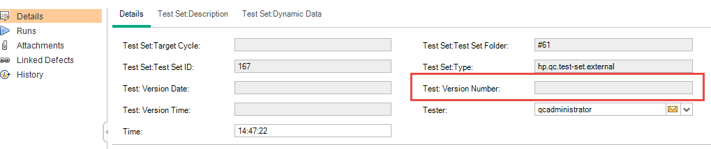
We think that this is a very common situation where typically test cases have different versions and maybe you are execution a version that it’s not the current one, so the plugin should be able to inform the version of the test executed.

